
Component Model
Controls REST APIs
Robotic Cognition System for Wheelchair
Unicamp

Table of Contents
1 Purpose of this Document 3
2 Components Design 4
2.1 Purpose 4
2.2 System Diagram 4
2.3 Move laser pan & tilt component 4
2.4 Move base 5
2.5 Stop base 6
2.6 Passage Condition 7
2.7 Source Code 7
3 References 8

Document Information
Project Name: | Robotic Cognition System for Wheelchair
Prepared By: | Tarcísio Franco de Carvalho | Document Version No: | 1.0
Title: | Component Model – Controls REST APIs | Document Version Date: | 29/Sep/2020
Reviewed By: |  | Review Date:
Distribution List
From | Date | Email

Acronyms
Acronym | Description
ROS | Robot Operational System
API | Application Programming Interface

Document Version History
Version  Number | Version  Date | Revised By | Description
1.0 | 29/Sep/2020 | Tarcisio | Initial Version

Purpose of this Document
Define how the related component works and its relation in the main system.

Components Design

Purpose
This set of API components do the interface between the user interface as a web application, mobile and others to the main operation components of the system as move the laser direction and move the robot base to the target point.

System Diagram
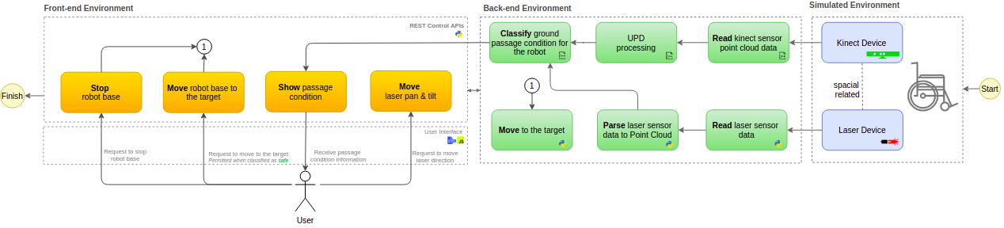

Move laser pan & tilt component
This component will receive laser direction pan and tilt values in degree, and will request the hardware to move the laser direction.

Component Input
- HTTP Method: POST
- Content-Type: application/json
- Path: /laser_move
- Body required
  - pan_value: (the pan value in degrees)
  - tilt_value: (the tilt value in degrees)

Component Output
- HTTP Response: 200 (After operation complete)

Component Processing

Below the main process flow for this component that occurs in cycles:

- Parse pan and tilt degree data to radians
- Publish the pan data in the ROS node that control the laser pan hardware
  - Node: /r2d2_laser_pan_controller/command
- Publish the tilt data in the ROS node that control the laser pan hardware
  - Node: /r2d2_laser_tilt_controller/command
- Return the HTTP result code 200

Move base
This component will receive the user request to move the base to the target point where the laser is pointing when it is classified as safe for the robot base.

Component Input
- HTTP Method: POST
- Content-Type: Not required
- Path: /base_move
- No body required

Component Output
- HTTP Response: 200 (After operation complete)

Component Processing

Below the main process flow for this component that occurs in cycles:

- Get the following current data:
  - laser pan
  - laser tilt
  - laser range
- Call the move base component passing the above input data
- Wait for completion feedback of the move base component
- Return HTTP result code 200

Stop base
This component will receive the user request to stop the base when it is moving to a desired target point.

Component Input
- HTTP Method: POST
- Content-Type: Not required
- Path: /base_stop
- No body required

Component Output
- HTTP Response: 200 (After operation complete)

Component Processing

Below the main process flow for this component that occurs in cycles:

- Call the move base component to abort the current operation
- Wait for completion feedback of the move base component
- Return HTTP result code 200

Passage Condition
This component will return the passage condition as “safe” or “unsafe” considering where the laser is pointing.

Component Input
- HTTP Method: GET
- Content-Type: Not required
- Path: /passage_condition
- No body required

Component Output
- HTTP Response: 200 (After operation complete)
- Content-Type: application/json
- Body response:
  - {“passage_condition”: “safe”}

Component Processing

Below the main process flow for this component that occurs in cycles:

- Call the classify passage condition component
- Return HTTP result code 200 and passage condition classification in the HTTP body

Source Code
https://github.com/tarcisiofcarvalho/robot_cognition_system/blob/master/src/web_app.py

References

- ROS & Gazebo
  - Control: http://wiki.ros.org/ros_control
  - ROS and Gazebo Tutorial: http://wiki.ros.org/action/fullsearch/urdf/Tutorials/Using%20a%20URDF%20in%20Gazebo?action=fullsearch&context=180&value=linkto%3A%22urdf%2FTutorials%2FUsing+a+URDF+in+Gazebo%22
  - Pan & Tilt Gazebo Simulation: https://www.theconstructsim.com/pan-tilt-gazebo-simulation
  - Gazebo Joint Controller: http://gazebosim.org/tutorials/?tut=ros_control

